

**EXPERIMENT NO:04**

**Aim:** Sketch Activity Diagram & State Transition Diagram for our Project

**Tools:** IBM Rational Rose

**Theory:** The Unified Modelling Language includes several subsets of diagrams, including structure diagrams, interaction diagrams, and behaviour diagrams. Activity diagrams, along with usecase and state machine diagrams, are considered behaviour diagrams because they describe what must happen in the system being modelled.

Stakeholders have many issues to manage, so it's important to communicate with clarity and brevity. Activity diagrams help people on the business and development sides of an organization come together to understand the same process and behaviour. You'll use a set of specialized symbols—including those used for starting, ending, merging, or receiving steps in the flow—to make an activity diagram, which we’ll cover in more depth within this activity diagram guide.

Activity diagrams present a number of benefits to users. Consider creating an activity diagram to:

* Demonstrate the logic of an algorithm.
* Describe the steps performed in a UML use case.
* Illustrate a business process or workflow between users and the system.
* Simplify and improve any process by clarifying complicated use cases.
* Model software architecture elements, such as method, function, and operation.
* **Basic components of an activity diagram**
* **Action:**A step in the activity wherein the users or software perform a given task. In Rational Rose, actions are symbolized with round-edged rectangles.
* **Decision node:** A conditional branch in the flow that is represented by a diamond. It includes a single input and two or more outputs.
* **Control flows:** Another name for the connectors that show the flow between steps in the diagram.
* **Start node:** Symbolizes the beginning of the activity. The start node is represented by a black circle.
* **End node:** Represents the final step in the activity. The end node is represented by an outlined black circle.
* **Activity diagram symbols**

These activity diagram shapes and symbols are some of the most common types you'll find in UML diagrams.

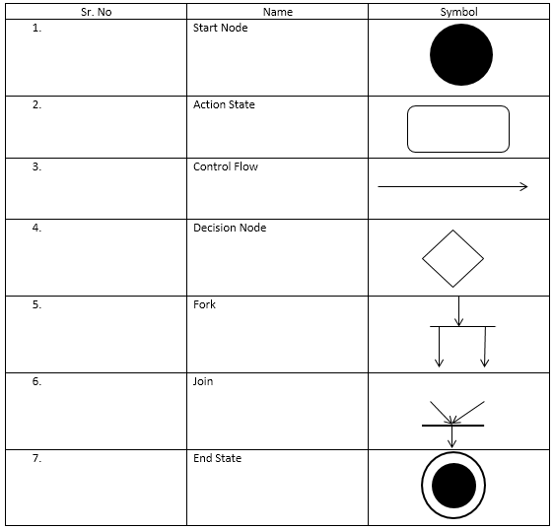

* **Activity Diagram for Bank Management System**

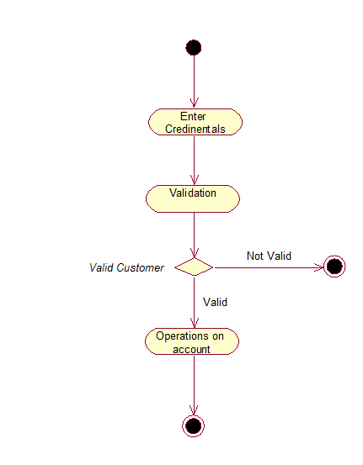

**Conclusion:**Activity diagrams are fairly easy to get the hang of, and will be useful for most projects because they "simply and quite plainly show how things work. Unlike many diagramming techniques, activity diagrams also enable the depiction of multiple choices and actors within a workflow, and they are easy

For Faculty Use

|  |  |  |  |  |
| --- | --- | --- | --- | --- |
| **CorrectionParameters** | **FormativeAssessment[40%]** | **Timely completionofPractical[40%]** | **Attendance /LearningAttitude[20%]** |  |
| **MarksObtained** |  |  |  |